Angular Routing

1. Generate a project with routing option

$ ng new routing-demo –routing

1. The next step is to add the below step inside index.html under title tag.



1. Configure the routes
   1. Import Routes and declare a variable of this type
      1. const routes: Routes=[];
   2. Inside this we keep our routes
   3. Each route is nothing but an object
   4. The object contains path which is reflected in the url and the component to rendered when we navigate to that corresponding path .

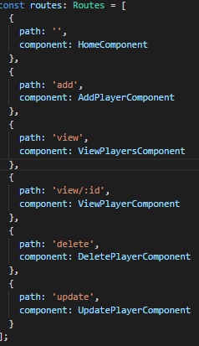

1. Don’t forget to import your components before using them .

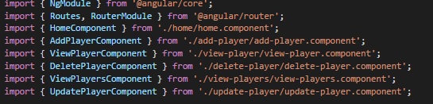

1. Inside @NgModule add routes variable as an argument to forRoot method of Router Module and export the module.
   1. UseHash is set to true if you want to skip ‘/’ in path values



1. In App.module.ts, import AppRouting Module and add it to imports
   1. 

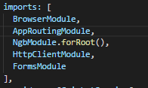

1. The routed views are displayed using <router-outlet> </router-outlet>
   1. We use this inside app.component.html to display our configured views

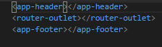

1. To make routing possible with anchor tags we use two special directives from Router package. The first one is routerLink directive which specifies the path we want to navigate to.
   1. We use this inside header.component.html to make navigation work in the anchor tag

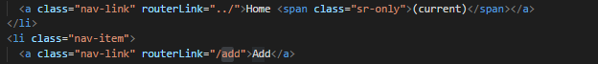

* 1. For example Add Component Looks like this
     1. Add Link



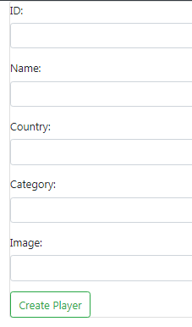

1. To make view player work here, We bind routerLink to player id as we have already declared path that accepts dynamic value in app.routing.module.ts
   1. Inside app.routing.module.ts

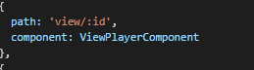

* 1. Now we bind current player id to the router link and send it dynamically to associated path



1. In view.player.component.ts , we retrieve the id and display player details

To do this we need to import ActivatedRoute and instantiate it in our constructor





Now we use this route variable gives us access to snapshot of current route and from the current route snapshot we get the id parameter from the url

And params helps us get parameter from API

